KT on Change Request:
Can create change from the incident or create new change and attach it to the incident.
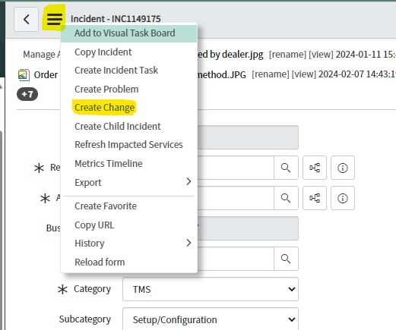

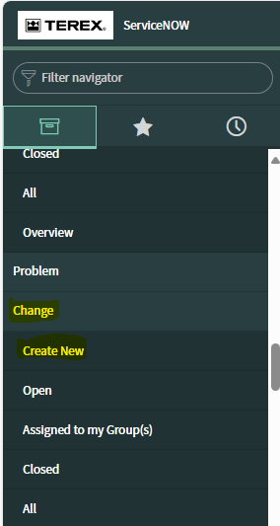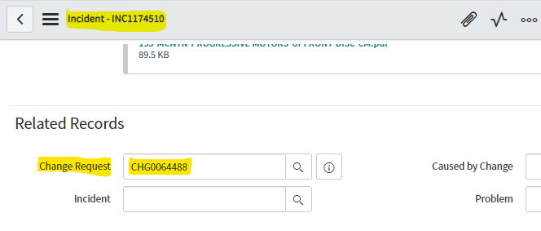

Below information need to be filled before submitting the change request
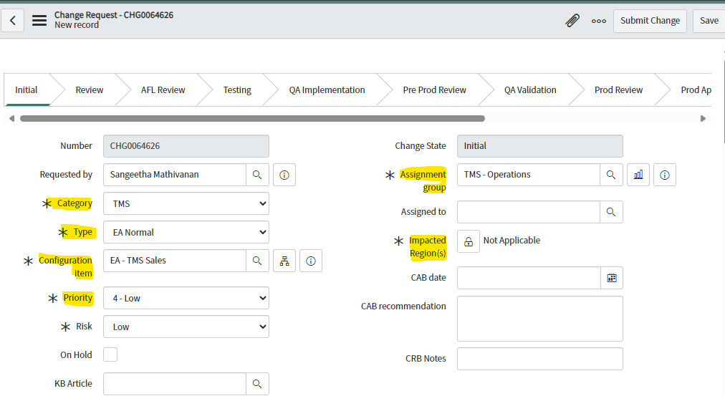
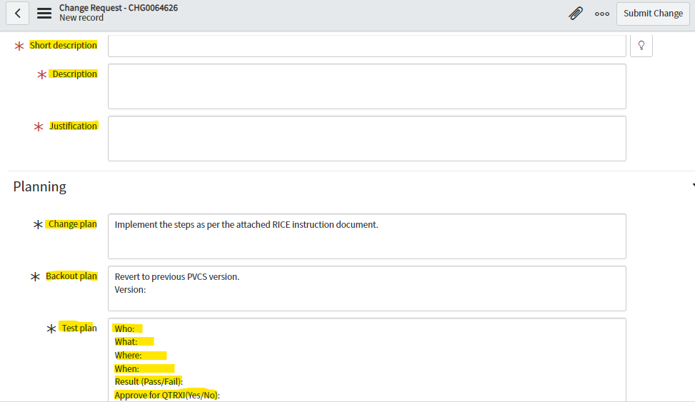

Create change task for QA migration
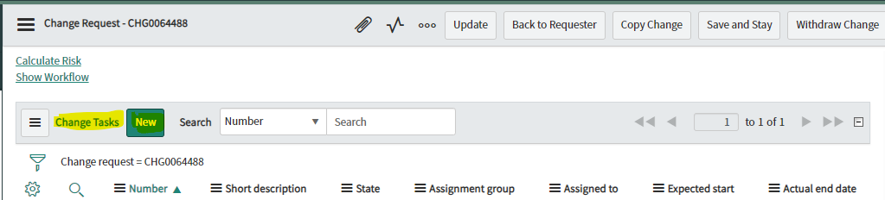

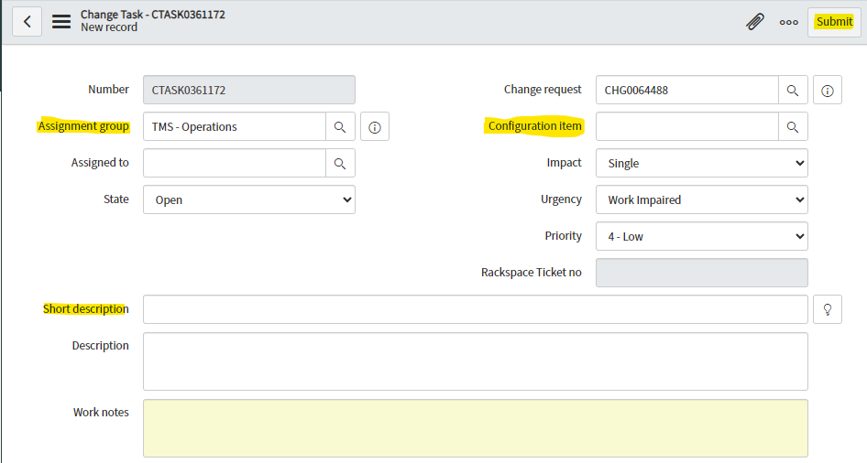
NOTE:
EA Normal - CTask will be created for PROD migration by Gary after cab call
EA Routine - CTask need to be created by us for PROD implementation.

Document to be attached in the CR:
- RICE document.
- Code review checklist.
- Approval mail from user (test/dev environment).
- MD080 document.
- Install instruction.
- Datafix document.

